**Filament Spooler Machine:**

**MKS GEN 1.4V Motherboard Pin layout:**

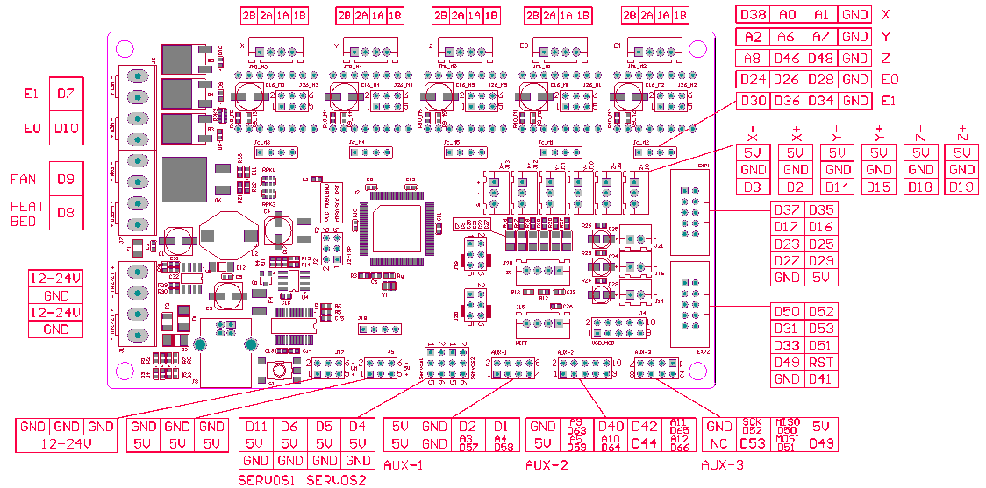

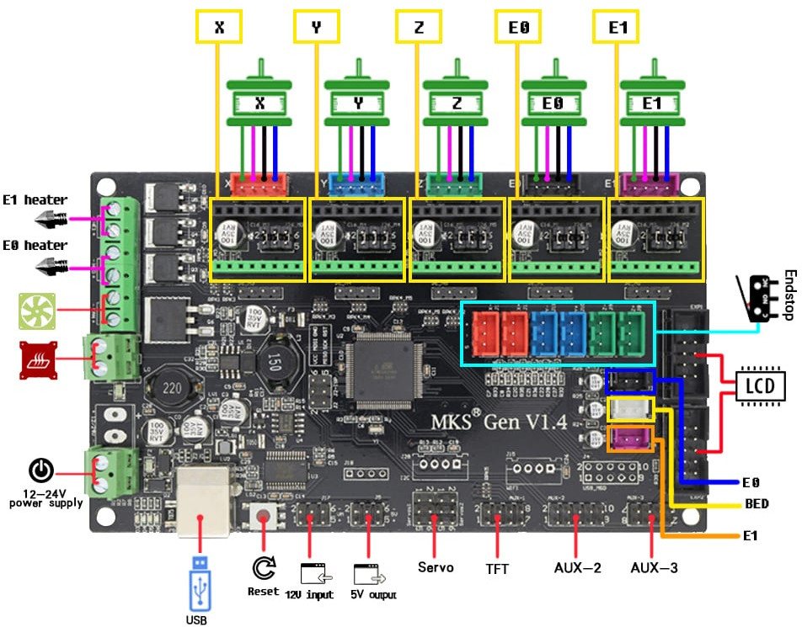

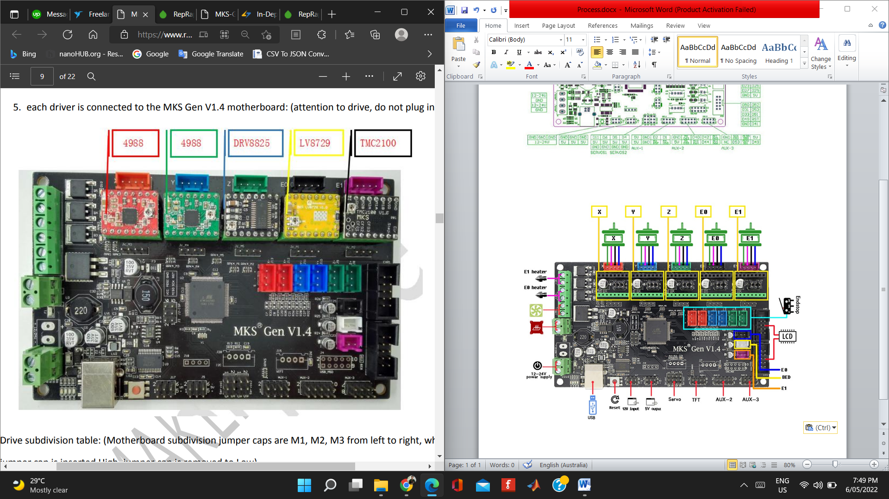

**RepRap Discount Smart Controller:**

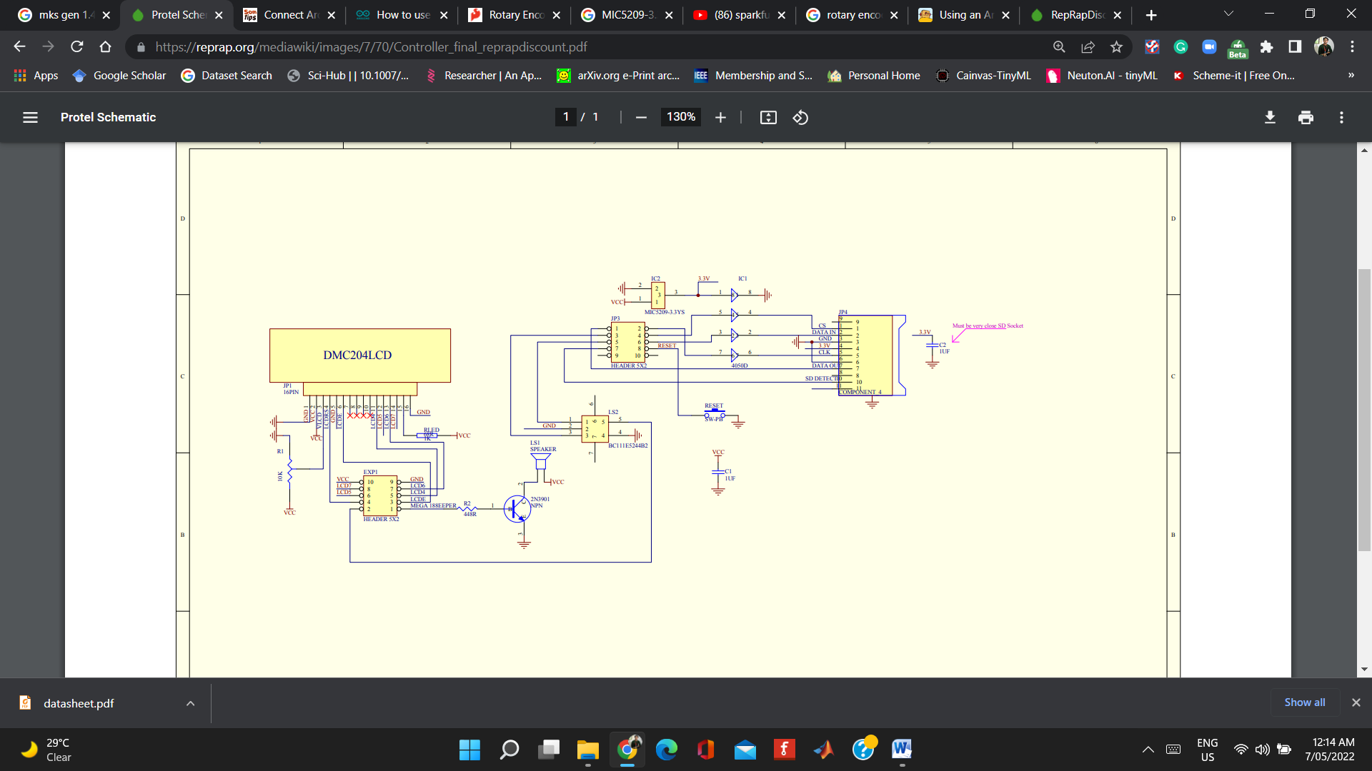

Rotary Encoder

**Stepper Motors:**

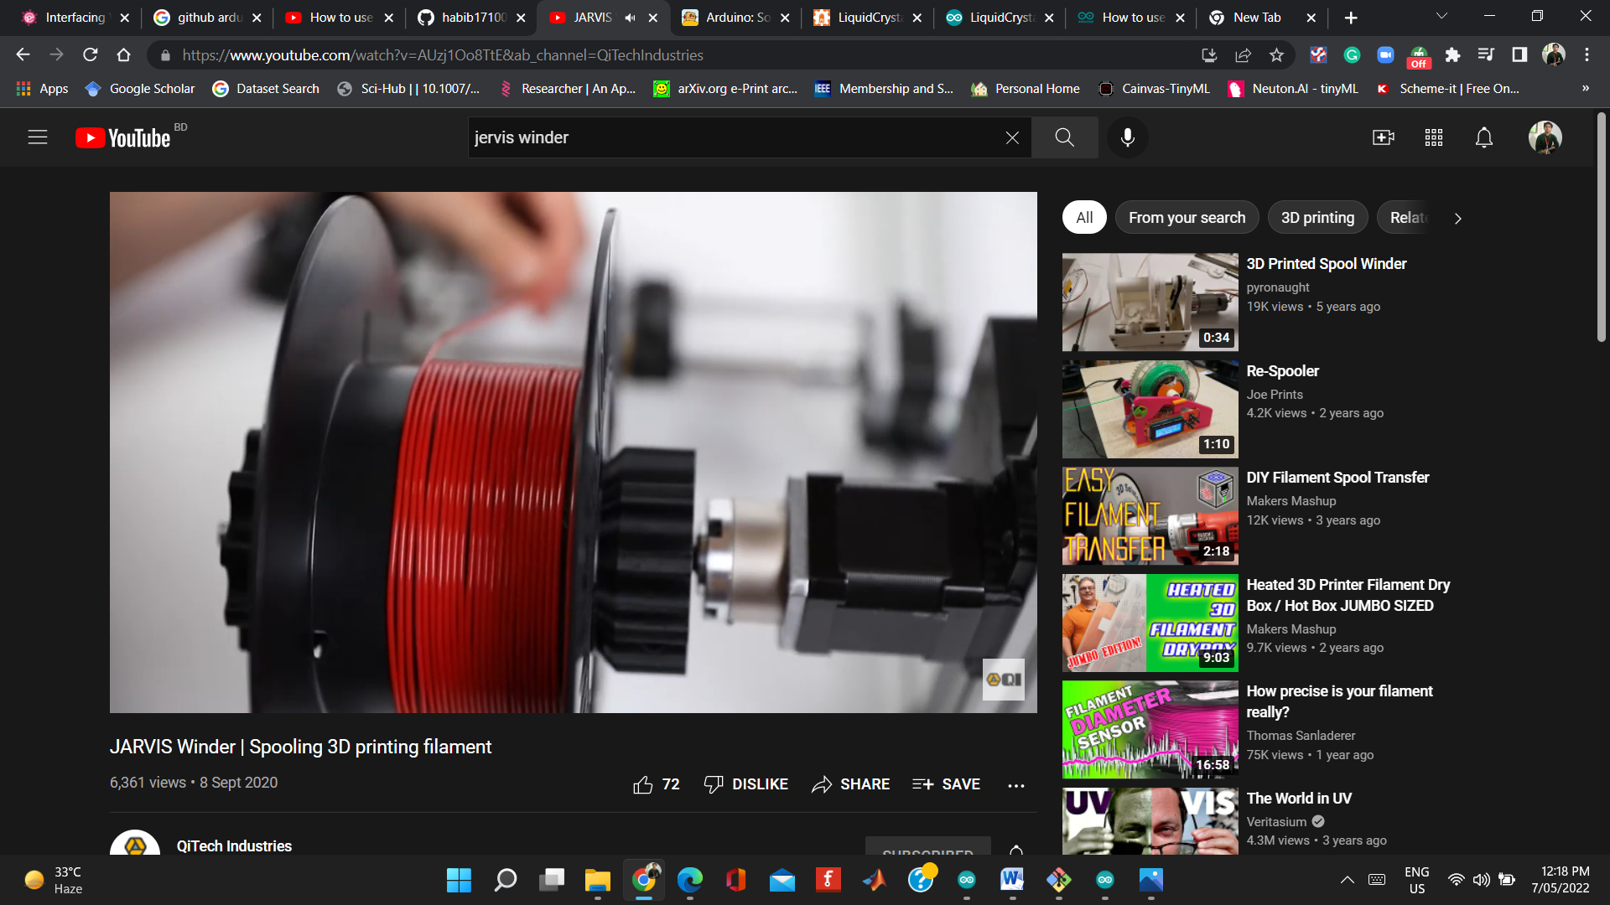

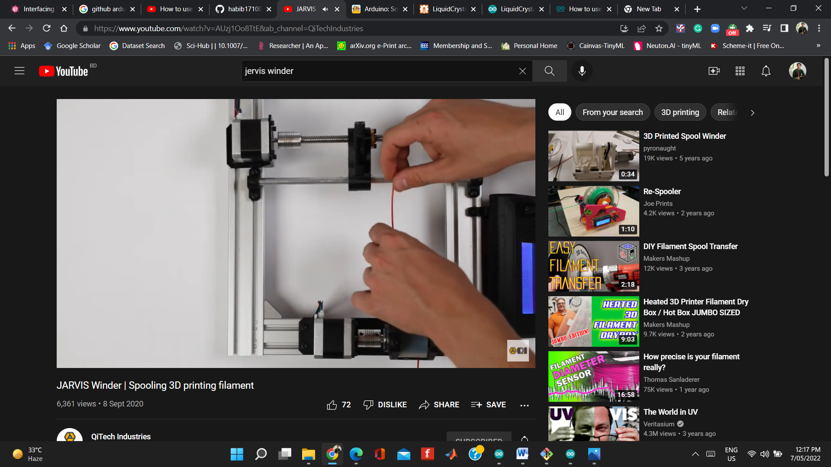

**Connections with MKS GEN 1.4V:**

**1. Stepper Motor:**

|  |  |  |  |  |
| --- | --- | --- | --- | --- |
| StepperNo | EN | STEP | DIR | GND |
| X | 38 | A0 | A1 | GND |
| Y | A2 | A6 | A7 | GND |
| Z | A8 | 46 | 48 | GND |
| E0 | 24 | 26 | 28 | GND |
| E1 | 30 | 36 | 34 | GND |

**2. Rotary Encoder:**

|  |  |  |  |
| --- | --- | --- | --- |
| Pin name | Pin no in encoder | IN MKS | IN EXP2 |
| SW | 5 | D35 | 2(EXP1) |
| DT(OUTA) | 1 | D33 | 5 |
| CLK(OUTB) | 3 | D31 | 3 |

**3. LCD:**

|  |  |  |
| --- | --- | --- |
| LCD PIN | IN EXP1 | IN MKS |
| rs | 4 | D16 |
| en | 3 | D17 |
| d4 | 5 | D23 |
| d5 | 6 | D25 |
| d6 | 7 | D27 |
| d7 | 8 | D29 |
| VCC | 10 | 5V |
| GND | 9 | GND |

**4. Buzzer:**

|  |  |  |
| --- | --- | --- |
| Buzzer pin | IN MKS | IN EXP |
| Positive end | D37 | 1 |

**5. Reset:**

|  |  |  |
| --- | --- | --- |
| Reset pin | IN MKS | IN EXP |
| Positive end | RST | 8 |

**GUI: (Winder)**

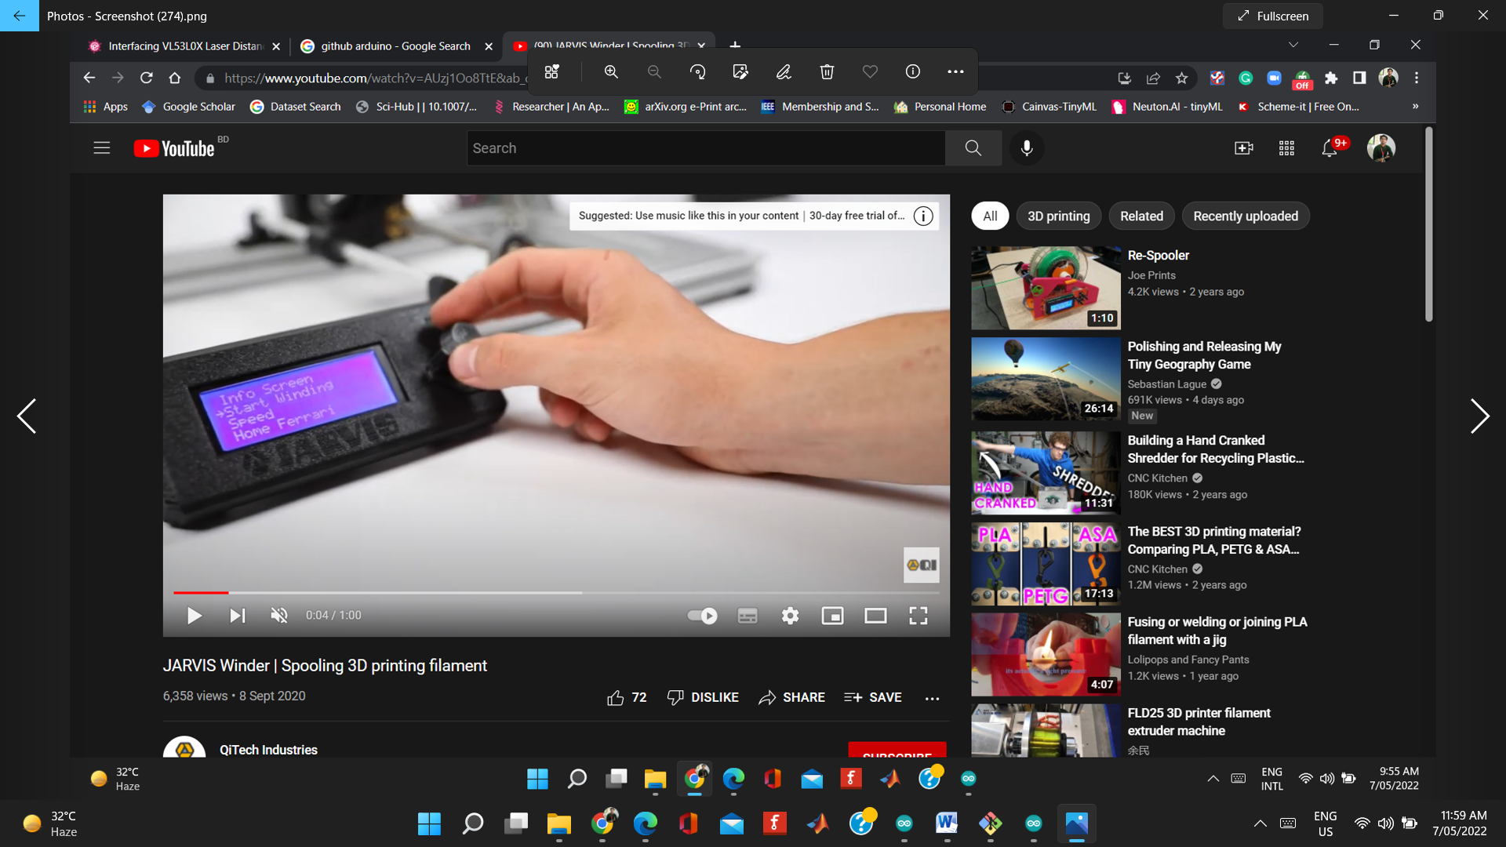

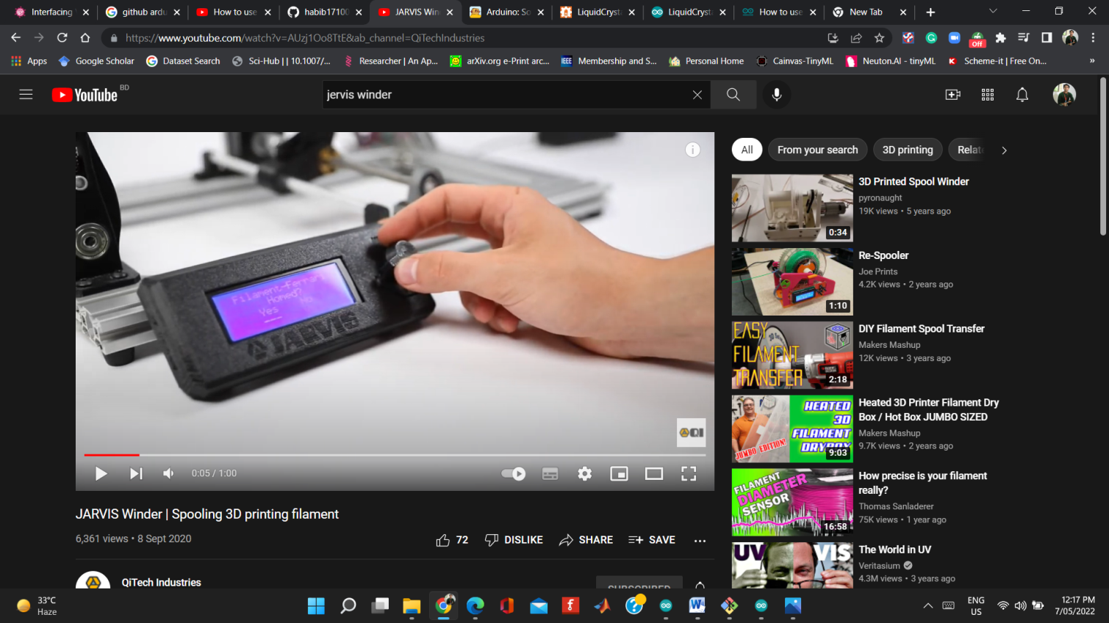

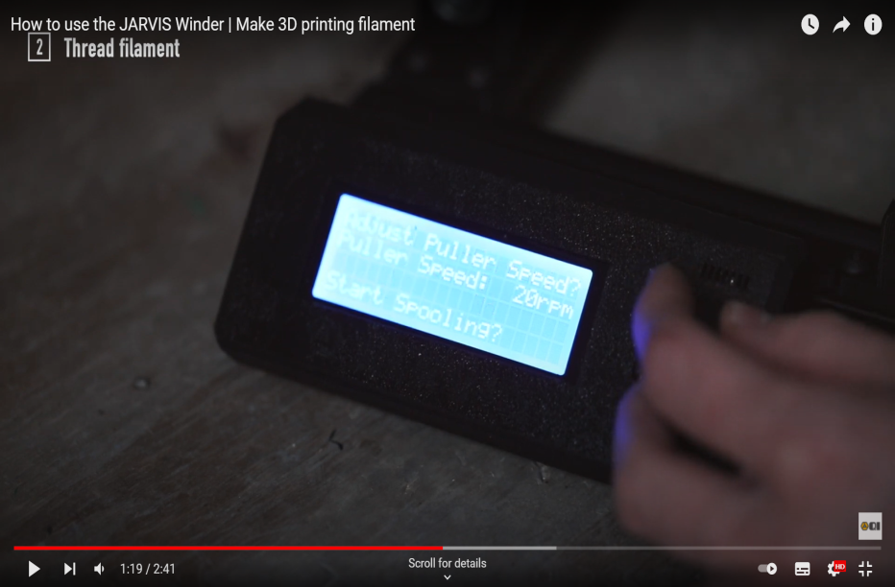

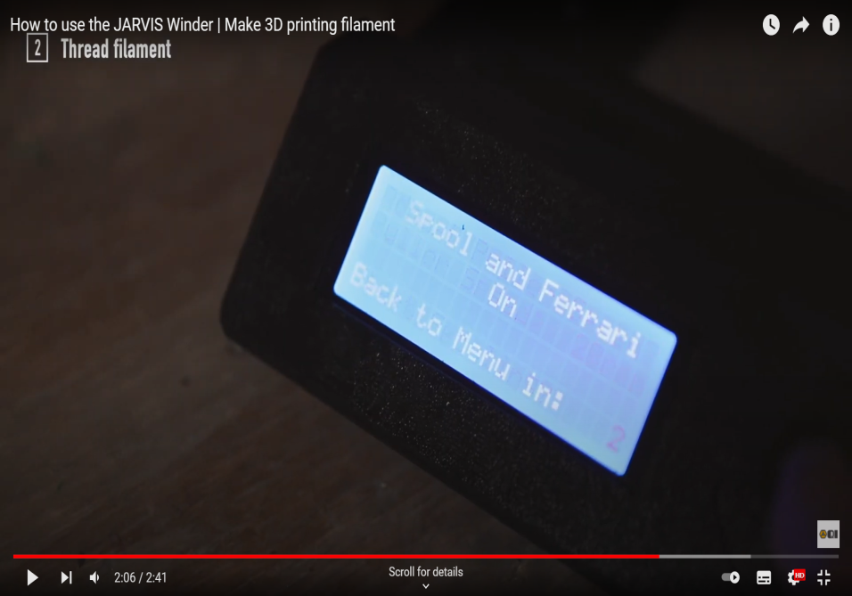

**Calibration:**

